**HADOOP COMMANDS**

1. To list contents of root folders

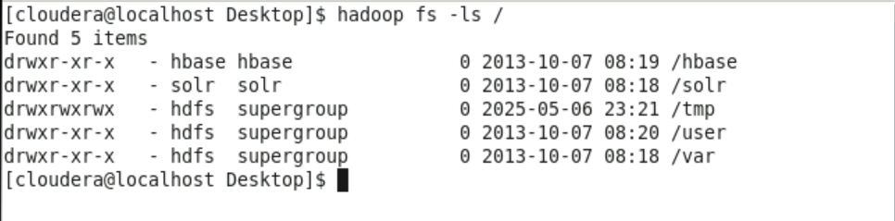

1. To list contents of directory

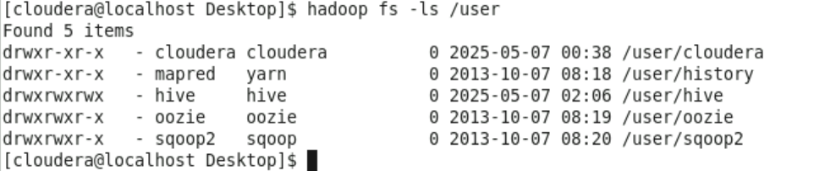

1. To create folder



1. To copy file from source location to destination location



1. To print contents of file to terminal





1. To check health of details of file

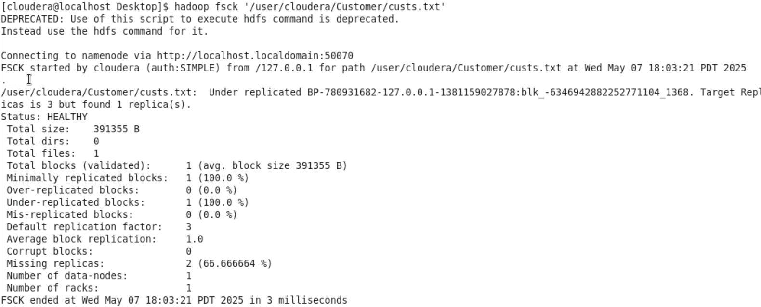

1. To set replication factor



1. To delete file from folder

